**EXP 6**

**6.1. let name = "John Doe";**

**let age = 30;**

**let isStd = false;**

**console.log("Name:", name);**

**console.log("Age:", age);**

**console.log("Is Student:", isStd);**

**console.log("Data type of name:", typeof name);**

**console.log("Data type of age:", typeof age);**

**console.log("Data type of isStudent:", typeof isStd);**

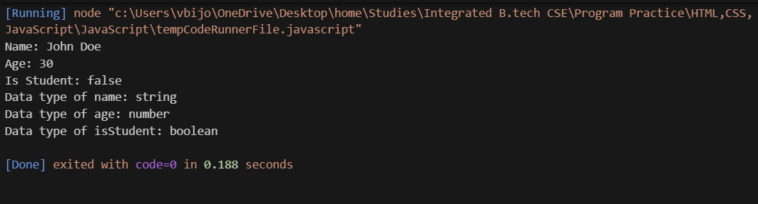**Output:**

**6.2. let a = 15;**

**let b = 4;**

**let s = a + b;**

**let diff = a - b;**

**let p = a * b;**

**let q = a / b;**

**let r = a % b;**

**console.log("Addition :", s);**

**console.log("Subtraction:", diff);**

**console.log("Multiplication:", p);**

**console.log("Division:", q);**

**console.log("Modulus:", r);**

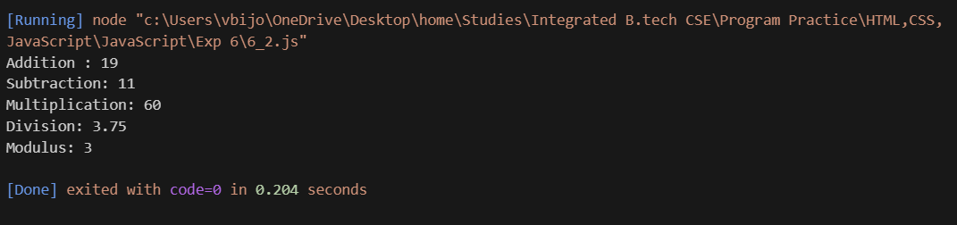**Output:**

**6.3**

**function calc(num1, num2, op) {**

**let r;**

**switch (op) {**

**case '+':**

**r = num1 + num2;**

**break;**

**case '-':**

**r = num1 - num2;**

**break;**

**case '*':**

**r = num1 * num2;**

**break;**

**case '/':**

**if (num2 === 0) {**

**return "Error: Division by zero is not allowed.";**

**}**

**r = num1 / num2;**

**break;**

**default:**

**return "Error: Invalid operator. Please use +, -, *, or /.";**

**}**

**return `The result of ${num1} ${op} ${num2} is ${r}`;**

**}**

**console.log(calc(10, 5, '+'));**

**console.log(calc(10, 5, '-'));**

**console.log(calc(10, 5, '*'));**

**console.log(calc(10, 5, '/'));**

**console.log(calc(10, 0, '/'));**

**console.log(calc(10, 5, '%'));**

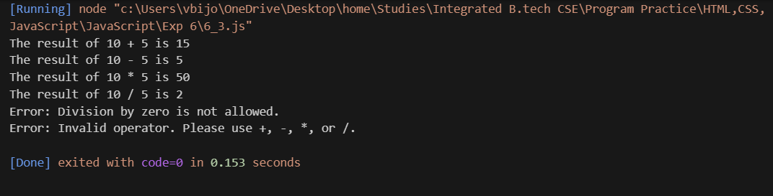**Output:**

**6.4. let age = prompt("Please enter your age:");**

**age = parseInt(age); // Convert the input string to a number**

**// Check voting eligibility**

**if (age >= 18) {**

**console.log("Eligible to vote");**

**} else {**

**console.log("Not eligible to vote");**

**}**

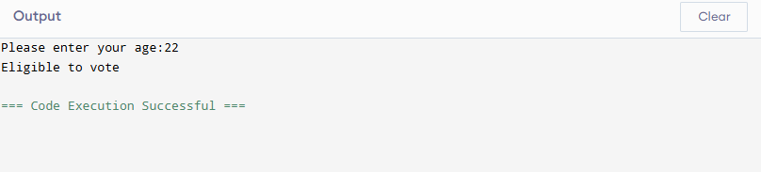**Output:**

**6.5. let mks = prompt("Enter your marks:");**

**mks = parseInt(mks);**

**if (mks >= 90) {**

**console.log("Grade A");**

**} else if (mks >= 75) {**

**console.log("Grade B");**

**} else if (mks >= 50) {**

**console.log("Grade C");**

**} else {**

**console.log("Fail");**

**}**

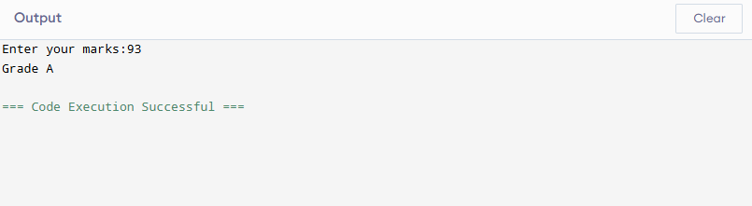**Output:**

**6.6. let dayNo = prompt("Enter a number (1-7):");**

**let dayNo = parseInt(dayNo); // Convert the input string to a number**

**let dayName;**

**switch (dayNo) { // Use the parsed integer**

**case 1:**

**dayName = "Monday";**

**break;**

**case 2:**

**dayName = "Tuesday";**

**break;**

**case 3:**

**dayName = "Wednesday";**

**break;**

**case 4:**

**dayName = "Thursday";**

**break;**

**case 5:**

**dayName = "Friday";**

**break;**

**case 6:**

**dayName = "Saturday";**

**break;**

**case 7:**

**dayName = "Sunday";**

**break;**

**default:**

**dayName = "Invalid input. Please enter a number between 1 and 7.";**

**}**

**console.log(dayName);**

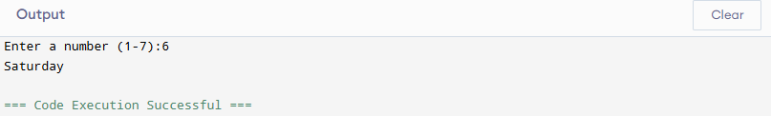**Output:**

**6.7. let n = prompt("Enter a number to check if it's even or odd:");**

**n = parseInt(n);**

**if (n % 2 === 0) {**

**console.log("Even number.");**

**} else {**

**console.log("Odd number.");**

**}**

**let n1 = prompt("Enter the first number:");**

**let n2 = prompt("Enter the second number:");**

**let n3 = prompt("Enter the third number:");**

**n1 = parseInt(n1);**

**n2 = parseInt(n2);**

**n3 = parseInt(n3);**

**let l;**

**if (n1 >= n2 && n1 >= n3) {**

**l = n1;**

**} else if (n2 >= n1 && n2 >= n3) {**

**l = n2;**

**} else {**

**l = n3;**

**}**

**console.log(`The largest number is ${l}.`);**

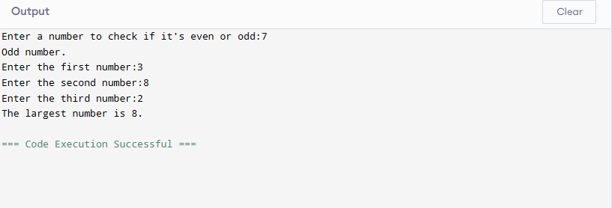**Output:**